R-SQUARED
R-squared is a metric of correlation that is easy to compute and intuitive to interpret.
We are already familiar with correlation and the standard metric of it, plain old R …
- … correlation values that are close to 1 or -1 are good and tell you that 2 quantitative variables (i.e. weight and size) are strongly correlated.
- … correlation values close to 0 are lame
Why should we care about R-squared ?; we already have regular R.
R-squared is very similar to regular R, but …
- … it is easy and intuitive to calculate
- … interpretation is easier
  - It is not obvious that R = 0,7 is twice as good as R = 0,5
  - R^2 = 0,7 is what it looks like, 1,4 times better that R^2 = 0,5
Let´s start with an EXAMPLE …
Suppose we have n (7) measurements for mouse weight and size (we want to predict weight given size) … we plot the data … we draw the mean for the weight … and we also fit a line using least squares:
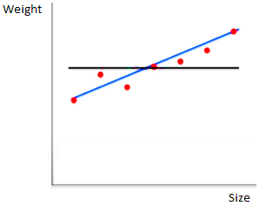
Does the blue line fit the data better than the mean ? If so, how much better ?
By eye, it looks like it does; we quantify that difference using R-squared !
$$R^{2}=\frac{Var\left(mean\right)-Var\left(fit\right)}{Var\left(mean\right)}=\frac{SSR\left(mean\right)-SRR\left(fit\right)}{SSR\left(mean\right)}$$
$$0≤R^{2}≤1$$
$$Var\left(mean\right)=32$$
$$Var\left(fit\right)=6$$
$$R^{2}=\frac{32-6}{32}=0,81$$
There is 81% less variation around the fitted line than the mean … or … the size-weight relationship accounts for 81% of the variation in mouse weight.
This means that most of the variation in data is explained by the size-weight relationship.
Here is another EXAMPLE …
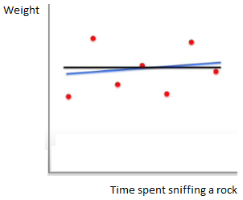
$$Var\left(mean\right)=32$$
$$Var\left(fit\right)=30$$
$$R^{2}=\frac{32-30}{32}=0,06$$
There is only 6% less variation around the fit than the mean … or … the sniff-weight relationship accounts for 6% of the variation in mouse weight.
This means that hardly any of the variation in the data is explained by the sniff-weight relationship.
The moral is …
Now, when someone says… ´the statistically significant R-squared was 0,9´ … you can think to yourself … very good! The relationship between the 2 variables explains 90% of the variation in the data!
And when someone else says … ´the statistically significant R-squared was 0,01´ … to can think to yourself … Dag! Who cares if the relationship is significant, it only accounts for 1% of the variation in the data … something else must explain the remaining 99%
What about plain old R ? How is it related to R-squared ?
R-squared is just the square of R … when someone says … ´ the statistically significant R was 0,9 … you can think to yourself … 0,9 times 0,9 = 0,81, so the relationship between the 2 variables explains 81% of the variation in the data!´
One last EXAMPLE …
How much better is R = 0,7 than R = 0,5 ?
Well, if we convert those numbers to R-squared we see that:
- R^2 = 0,7^2 = 0,5 (50% of the original variation is explained)
- R^2 = 0,5^2 = 0,25 (25% of the original variation is explained)
With R-squared is easy to see that the first correlation is twice as good as the second.
That said, R-squared does no indicate the direction of the correlation because squared numbers are never negative.
If the direction of the correlation isn´t obvious, you can say … ´the 2 variables were positively (or negatively) correlated with R^2 = …´
Main ideas …
R-squared is the percentage of variation explained by the relationship between 2 variables.
If someone gives you a value for plain R, just square it to see what´s going on.

